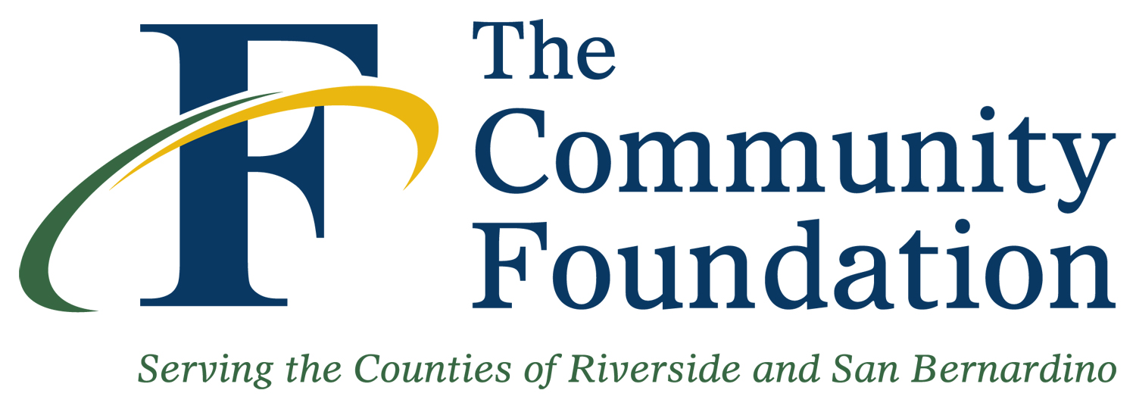   | 2022 EEC  Small Grant ApplicationDue: November 1, 2022

Organization / Agency Information
Organization/Agency Name: IE Hope
Physical Address: 5060 N. Mt View Ave City/State/Zip San Bernardino, CA 92407
Mailing Address: same City/State/Zip
CEO or Director: Kim Valverde Title: President
Phone: 909-999-8765 | Fax: 909-999-8765 | Email: IEHope@gmail.com
Contact Person: Kim Valverde Title: President
Phone: 909-999-8765 | Fax: 909-999-8765 | Email: IEHope@gmail.com
Web Site Address: www.IEHope.org |  | Tax ID: 1234567
Organization Type: □501c3 Nonprofit □Public School K-12 □Private/Charter School K-12

Program / Grant Information

Program/Project Name: EEC Small Grant | Location: Riverside or San Bernardino
Amount of Grant Request: $20,000 | Total Organization Budget: $50,000
Purpose of Grant Request (one sentence): Funds will be awarded as scholarships to families with children currently battling cancer.

Signatures
Board President / Chair: (Print name and Title) Signature: Date:
Kim Valverde, President Kim Valverde 10/29/22

Executive Director/President: (Print name and Title) Signature: Date:

Kim Valverde, President Kim Valverde 10/29/22

2022 EEC SMALL GRANT APPLICATION

Organization Background

IE Hope is a nonprofit out of San Bernardino, CA. The foundation was birthed in 2019 from a place of tragedy and despair. After experiencing the hardship of pediatric brain cancer and losing a close family member to this horrible disease, we knew something had to be done to help families who are currently going through the same hardship. We understand the feeling of hopelessness in times like this and it is our goal to bring hope and lessen financial burdens for families whose children are currently in the hospital fighting for their lives.
In the last three years, IE Hope has raised over $100,000 and has given over $75,000 to families in need. Since 2019 we have been giving away Easter baskets to children in the community, give away school supplies, feed families at Thanksgiving, feed and gift families at Christmas, and have an annual Kickball Tournament and Car Show event that is our biggest fundraiser of the year.

Project Information

This particular project will help families with children with cancer. IE Hope will visit Loma Linda Medical Center, Pediatric Oncology Unit, to love on the families and meet their needs by gifting them with basic necessities like socks, blankets, food cards and gas cards, things that are essential while either staying in the hospital with your sick child or going back and forth from home to the hospital. Our resources will be available to any family with a child in that specific unit during the week of our visit. IE Hope will coordinate dates and times of visits.
Our ultimate goal is to bring hope to hurting hearts. We will accomplish this goal by loving on these families. We will show them the love of God by meeting their immediate physical and emotional needs. Each family member present will receive a pair of fluffy socks, and a new blanket. The parents will receive a food gift card and a gas gift card. We will offer prayer to the families and will be an ear to listen and a shoulder to cry on.
We do not ask anything from our families in return. Rather, we pour out on them to show them that Jesus loves them, He knows what they are going through, and there’s others who understand their pain, anger, confusion, hopelessness, and any other type of discomfort this situation brings. We others to be able to experience God’s goodness and to know that in Him, there’s always hope.

Use of Grant Funds

The grant funds will be used to purchase the supplies needed: socks, blankets, food cards, and gas cards. The funds will also go toward the medical bills scholarship fund. IE Hope helps families with financial hardships, specifically due to outstanding medical bills. Families request assistance by applying for the scholarship on our website. The board then decides how much to grant the family based on need.

IE Hope thanks you for your time and consideration.

2022 EEC SMALL GRANT APPLICATION

Organization: IE Hope

Project Name: Children with Cancer
Amount Requested from EEC: $20,000

Prepared by: Kim Valverde

V. Project Budget
Please provide a detailed line-item budget for your project by completing the budget form below. Include all sources of funding for the proposed project or program. The maximum request from EEC (Column C) is $20,000

Line Item Request | Line Item Explanation | Support From Your Agency  (A) | Support From Other Funders (B) | Requested Amount From EEC  (C) | Line Item Total of Project  (D)  (A+B+C=D)
1 | Children with cancer | 20,000 | 10,000 | 20,000 | 50,000
TOTALS: |  | 20,000 | 10,000 | 20,000 | 50,000

